Assignment for 09-06-2020

# Assignment 1

**Description of problem:**: Create Login Form using Bootstrap icons

**Deliverable (s):** Bootstrap

**Format, Place, and Reference:** Bootstrap

# Assignment 2

**Description of problem:** Create a navbar with fields Home,Contact us, About us, log in.

**Deliverable (s):** Bootstrap

**Format, Place, and Reference:** Bootstrap

# Assignment 3

**Description of problem:** Create a menu by using a few HTML elements along with some CSS styles. Click on the button to show the menu with a fading effect.

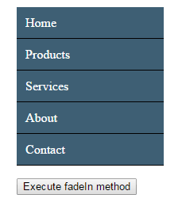

**Deliverable (s):** HTML, CSS, Bootstrap, JQuery

**Format, Place, and Reference:** Bootstrap, JQuery.

**Note:** Submit the Assignment before 4 pm (10-06-2020) in moodle site.